NEWSLETTER 3
February 2015
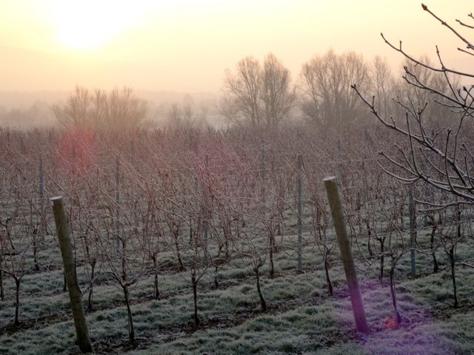
We are now well into the start of the annual cycle in the vineyard. The weather has at last dried up enough for us to start the winter pruning. This is when we remove most of the shoots that the vine grew in the previous year to leave one cane that will be tied down to the wire to produce this years shoots and fruit. The photos below give you some idea of what happens. All the cut shoots are then pulled out from the wires and mulched in the vineyard or removed and burnt.
BEFORE PRUNING SAME VINE AFTER PRUNING
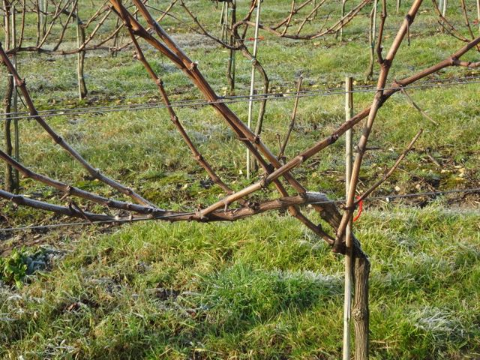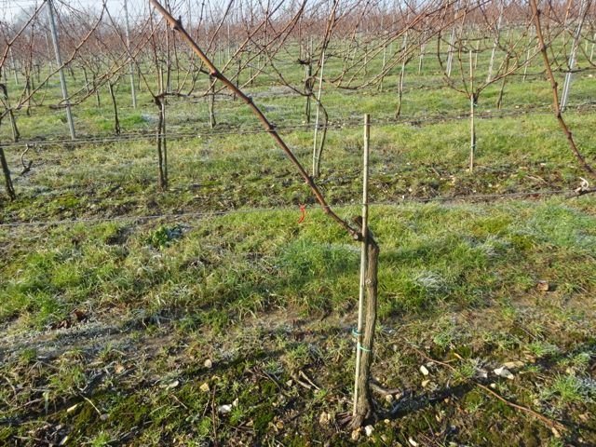
This is all done by hand. With over 40,000 vines to prune – you can imagine this takes some time!
At this time of year we also allow our four ‘pet’ sheep in the vineyard to help keep the grass down and add their own manure. We cannot keep sheep in the vineyard year round as they would show far too much interest in the new vine shoots and get in the way of the equipment!
Here is Sean, a Jacob sheep, on a frosty morning in the vineyard – looking warmer than we felt!
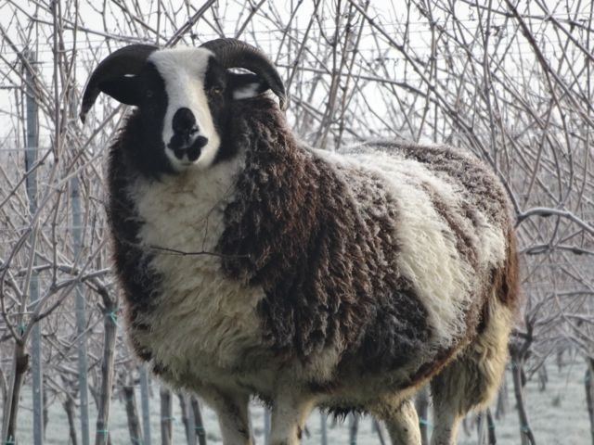

In the winery we have nearly finished the task of blending the 2014 wines. This involves trying lots of samples of each wine from the different tanks in different combinations to come up with what we think works best. The photo below shows the line up in the lab.
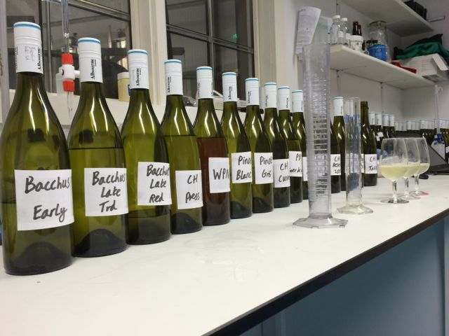
We also undertake stability trials to prepare the wines for bottling. We need to ensure that neither a protein haze will form if the bottle is stored in conditions that are too warm nor ‘tartrate’ crystals if it is stored in very cold conditions. Wine should be bright and clear when poured from the bottle and free of any hazes or deposits – harmless though these are. We are very hopeful about the standard and quality of the 2014 blends and look forward to launching them later this Spring.
Our website is now updated with a Tours & Tastings bookings page for 2015 dates – so please do come for a visit if you can.
In addition we will be sampling our wines at two events in Brighton if you are near there.
Firstly, the 2015 Brighton Wine Fair which takes place at Hotel du Vin on Saturday 25th April from 12,30pm - 4pm. This is great opportunity for wine lovers to sample and buy wines from Brighton wine merchants and Sussex wine estates under one roof. Exhibitors include Twenty One Wines, Majestic Brighton & Hove, Bolney Wine Estate, Albourne Estate, WSET, Plumpton Estate and Sussex Wine School. Prizes and guess the grape competitions. Charcuterie plates from Hotel du Vin. Buy your tickets at www.brightonwinefair.com
Secondly, the Brighton & Hove Food and Drink Festival Market on Saturday 30th and Sunday 31st May 2015 from 10am – 6pm. For details see www.brightonfoodfestival.com
Hope to see you in 2015.
Alison

IF YOU WOULD PREFER NOT TO RECEIVE ANY FUTURE NEWSLETTERS PLEASE EMAIL ME AND I’LL REMOVE YOU FROM THE LIST

